1. Data Description & Overview
The foundation of this case study relies on a robust dataset detailing customer behavior, product engagement, and support interactions.
- Dataset Size: The dataset contains 2000 records and 20 features, providing a comprehensive view of the customer lifecycle.
- Key Features: The initial feature space encompassed a variety of metrics, prominently including avg_monthly_product_usage, num_distinct_features_used, last_login_days_ago, support_ticket_count, avg_resolution_time_hrs, support_satisfaction_score, emails_opened_last_30d, and num_analyzers_installed.
- Target Variable: The primary target variable is the churn_risk_flag, which acts as the binary indicator for whether a customer is likely to abandon the product.
2. Exploratory Data Analysis (EDA) & Feature Relationships
A thorough Exploratory Data Analysis (EDA) utilizing boxplots and density plots was conducted to understand the distribution of features and their direct relationship with the target variable (churn). Several critical conclusions were drawn:
- Product Engagement (Density Plots): Analysis of product usage density revealed a stark contrast between retained and at-risk customers. At-risk customers are distinctly characterized by lower avg_monthly_product_usage and a significantly higher number of last_login_days_ago. 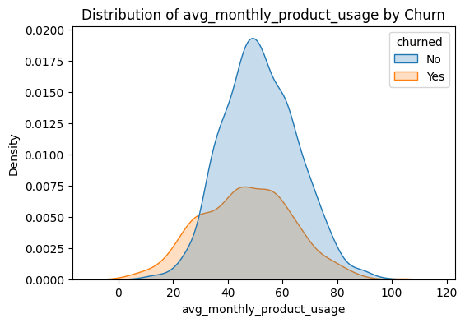
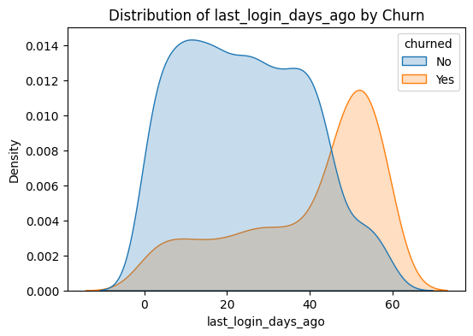
- Analyzer Installation (Boxplots): Boxplot distributions demonstrated that customers flagged as at-risk consistently have a lower num_analyzers_installed, indicating poor product adoption and integration.
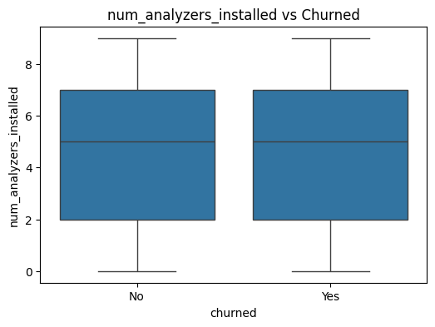
- The Support Ticket Anomaly: The EDA uncovered a counterintuitive relationship regarding customer support. Traditionally, one might assume fewer support tickets correlate with higher satisfaction and retention. However, the data clearly shows that at-risk customers raise fewer support tickets. In this ecosystem, a higher support_ticket_count indicates that the customer has more analyzers installed and is more deeply engaged with the product, making them highly valuable and less likely to churn.

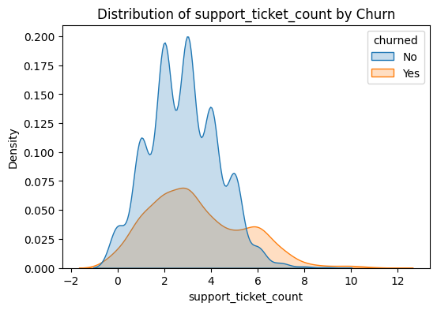

3. Feature Selection: Combined Score Metric
To ensure the machine learning models were trained on the most impactful data without introducing noise, a rigorous feature selection process was employed.
- Methodology: Features were evaluated using a combined score metric (incorporating Mutual Information (MI) and Random Forest Importance)to quantify their predictive power regarding the churn_risk_flag.
- Most Important Features: The combined scoring highlighted a select subset of features as the primary drivers of churn. The final selected features critical for model training were last_login_days_ago, support_ticket_count, avg_monthly_product_usage, and num_analyzers_installed.

Index | Feature | RF Importance | Mutual Info | Combined Score
0 | at_risk_flag | 0.265587 | 0.241972 | 20.422226
1 | last_login_days_ago | 0.154439 | 0.143411 | 11.767753
2 | support_ticket_count | 0.054714 | 0.043118 | 3.203051
3 | avg_monthly_product_usage | 0.070993 | 0.029373 | 2.57054
4 | emails_opened_last_30d | 0.02259 | 0.017175 | 0.873196
5 | avg_resolution_time_hrs | 0.046499 | 0.003153 | 0.359893
6 | customer_age_months | 0.035989 | 0.004163 | 0.23802
7 | customer_id | 0.049303 | 0 | 0.198004
8 | total_ps_spend | 0.045402 | 0 | 0.12749
9 | total_contract_value | 0.043714 | 0 | 0.096987
10 | survey_response_rate | 0.039779 | 0 | 0.025851
11 | num_distinct_features_used | 0.027371 | 0.003058 | 0.007754
12 | join_month | 0.025521 | 0.002689 | -0.050521
13 | support_satisfaction_score | 0.017431 | 0.003558 | -0.138187
14 | num_analyzers_installed | 0.024669 | 0 | -0.247239
15 | events_attended_last_6mo | 0.020239 | 0 | -0.327315
16 | software_lifecycle_stage | 0.016234 | 0.000886 | -0.339996
17 | industry | 0.013791 | 0.000616 | -0.40235
18 | region | 0.014939 | 0.000306 | -0.402458
19 | plan_tier | 0.010794 | 0.000221 | -0.483091

4. Machine Learning Models & Results (With and Without SMOTE)
Given that churn datasets are often highly imbalanced (with far fewer actual churners than retained customers), the modeling phase tested both Logistic Regression (LR) and Random Forest (RF) algorithms, both in their standard state and by applying SMOTE (Synthetic Minority Over-sampling Technique) to handle class imbalance.
- Standard Models (Without SMOTE):
  - Logistic Regression: Achieved a Precision of 74%, Recall of 78% and an f1 of 76%, and ROC-AUC: 0.8305465155425878.
  - Random Forest: Achieved a Precision of 73% , Recall of 70% and an f1 of 71% and ROC-AUC: 0.8065452811132309.
- Balanced Models (With SMOTE): * Applying SMOTE significantly altered the model's ability to identify the minority class (actual churners).
  - Logistic Regression (SMOTE): Yielded an Precision of 74% , Recall of 78% and an f1 of 76% and ROC : 0.8242902031197396
  - Random Forest (SMOTE): Yielded an Precision of 70% , Recall of 77% and an f1 of 73% and ROC : 0.7991387049713838
  - Gradient Boosting (SMOTE) : Yielded an Precision 68%, Recall 73%, F1-Score 71% and ROC : 0.8890587330639281.
- Model Selection for Production: The Gradient Boosted Model with SMOTE is highly recommended for production deployment. This decision is driven by its superior Recall score, which ensures the business minimizes false negatives (failing to identify a customer who is actually going to churn).

The Reasoning: It provides a strong balance of high recall (0.73) and a good ROC-AUC (0.79). In churn prediction, minimizing false negatives (failing to flag a customer who does churn) is critical, as it directly leads to lost revenue and missed retention opportunities. Gradient Boosting matches the recall of simpler models while providing superior robustness to noise in the data.

5. Business Strategies, Recommendations & Monitoring
Translating these data-driven insights into actionable business strategies requires a shift in how the company approaches customer success.
- Incentivize Deep Adoption: The business should target at-risk customers (those with low engagement and few analyzers) with specialized deals or onboarding campaigns specifically designed to encourage them to install more analyzers and engage more deeply with the platform.
- Shift the Support Paradigm: The company must embrace the finding that higher support needs equate to higher product engagement. Do not try to artificially minimize support tickets. Instead, encourage users to expand their product footprint (which naturally increases their support needs), as this makes the product indispensable to them and entices them to stay long-term.
- Continuous Monitoring & Drift Detection: Once the model is in production, it is vital to establish automated monitoring for data and concept drift.
  - Features to Monitor: The company must continuously track avg_monthly_product_usage, last_login_days_ago, and num_analyzers_installed. If the baseline distributions of these features begin to shift (Data Drift), or if their relationship with actual churn changes (Concept Drift), the production model will require retraining to maintain its predictive accuracy.

